[**CREATE AND CONFIGURE IBM CLOUD SERVICES**](https://careereducation.smartinternz.com/Student/guided_project_workspace/51379#collapse2)

**Creating Node-Red Service**

|  |  |
| --- | --- |
| **Date** | **4th November 2022** |
| **Team ID** | **PNT2022TMID28767** |
| **Project Name** | **IoT Enabled Smart Farming Application** |

**Step 1:**

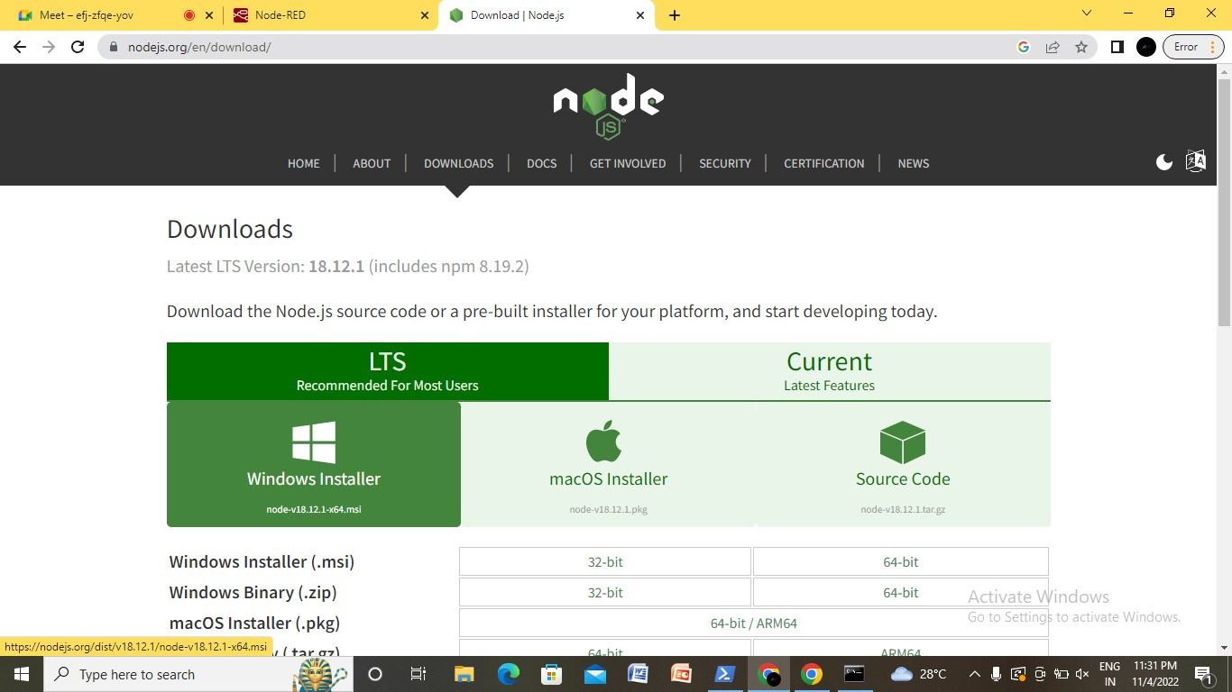

**Step 2:**

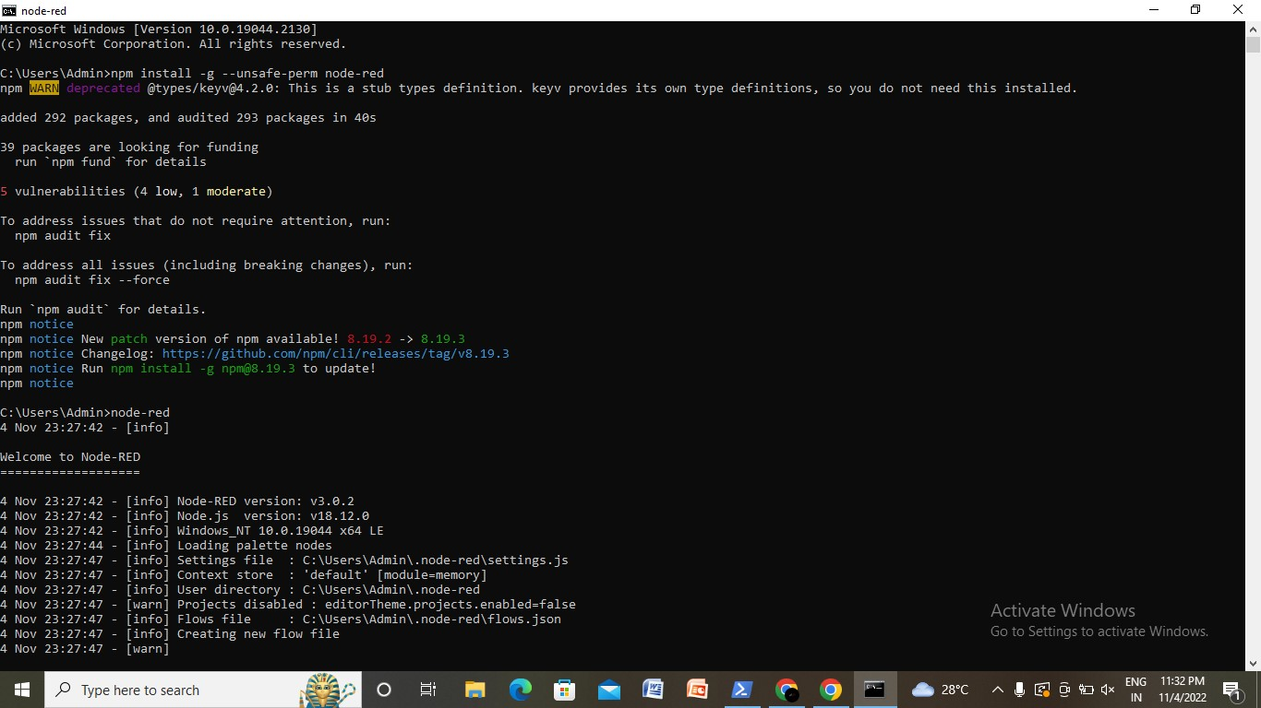

**Step 3:**

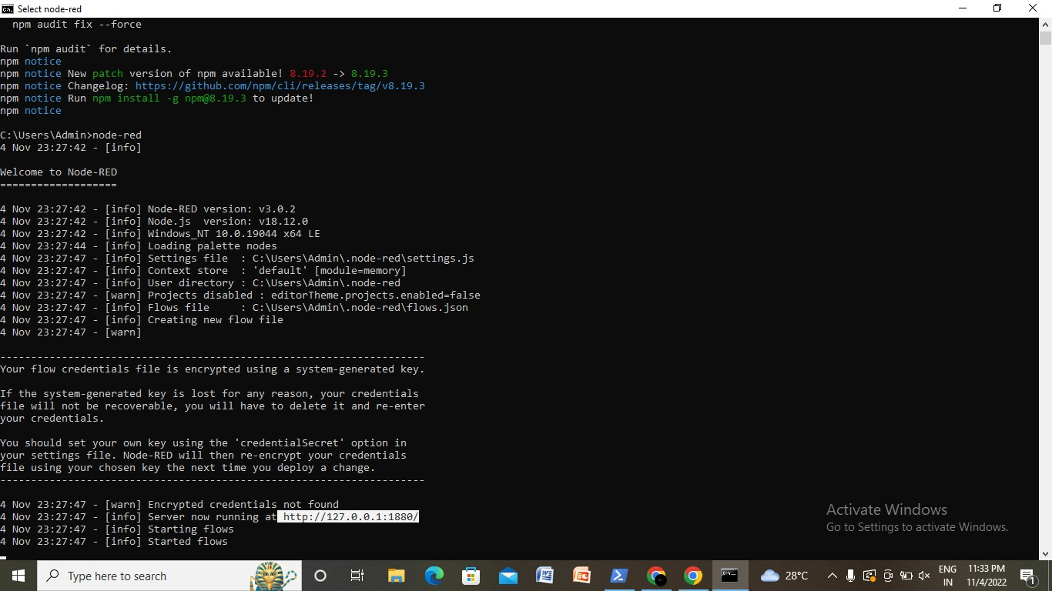

**Step 4:**

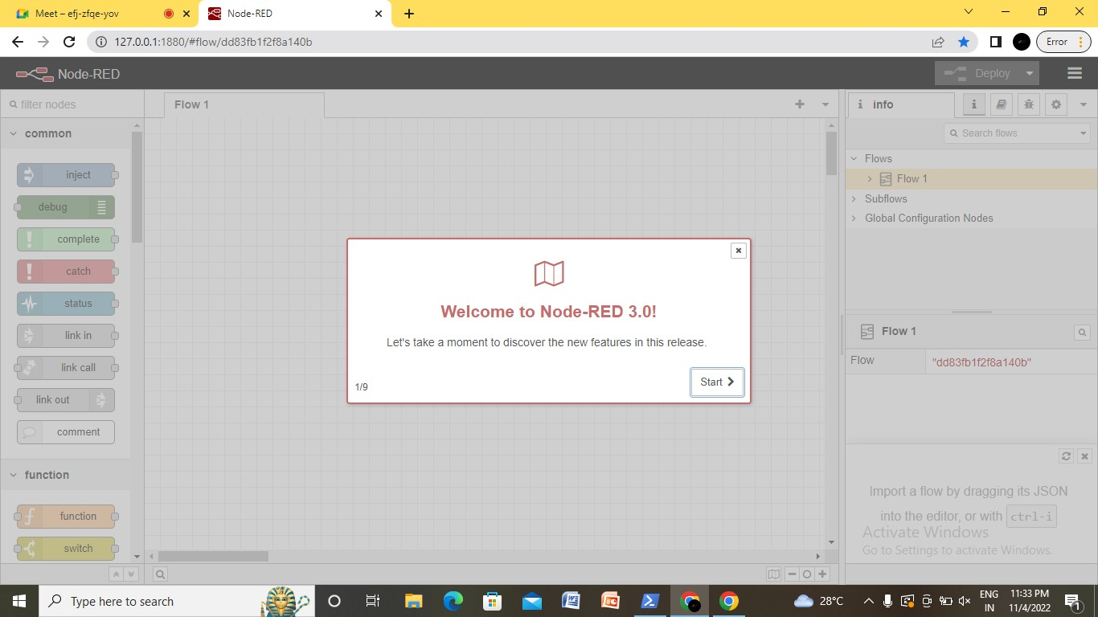

Successfully created Node-red Service.